Open5gs Guide

1. First download open5gs project from github(<https://github.com/Gradiant/5g-images>)
2. Extract zip file and Copy this project from windows into Oracle virtual box docker environment

(scp -r 5g-images docker@loalhost:/home/docker/)

1. Download docker-compose execution file from <https://github.com/docker/compose/releases/download/v2.28.1/docker-compose-linux-x86_64>
2. Copy docker-compose execution file into Oracle virtual box docker environment

Scp docker-compose-linux-x86_64 docker@localhost:/home/docker

1. Rename docker-compose-linux-x86_64 file name to docker-compose

mv docker-compose-linux-x86_64 docker-compose

1. Copy docker-compose execution file to usr/bin directory

cp docker-compose /usr/bin

1. Go to /5g-images/docs/open5gs-and-srsran-4g-usrp/

cd ./5g-images/docs/open5gs-and-srsran-4g-usrp/

1. Follow <https://github.com/Gradiant/5g-images/tree/main/docs/open5gs-and-srsran-4g-usrp/ReadME.md>
2. Run “docker-compose -f epc.yml up -d”
3. Edit register_subscriber.sh file

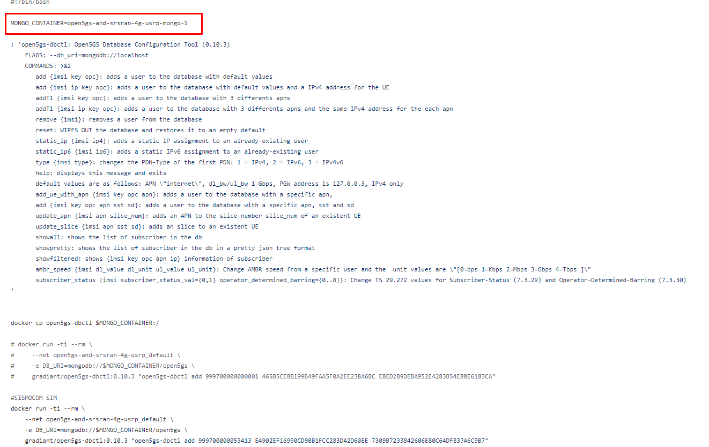

Run “vi register_subscriber.sh”

Edit it to open5gs-and-srsran-4g-usrp_mongo_1

1. Run “./register_subscriber.sh”
2. Copy uhd_images directory to /5g-images/ directory

scp -r uhd_images docker@localhost:/home/docker/5g-images/

1. Run “ docker-compose -f srs-enb.yaml up -d”
2. Map 9999 port in oracle virtual box to 9999 local port

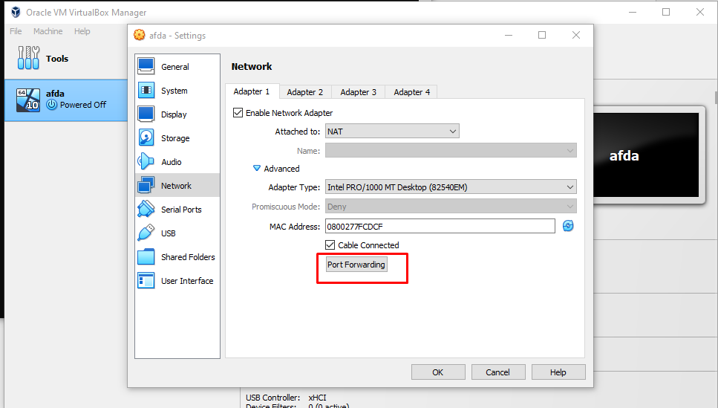

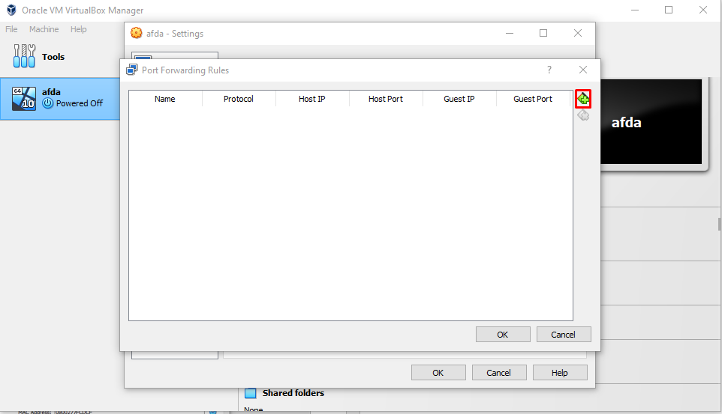

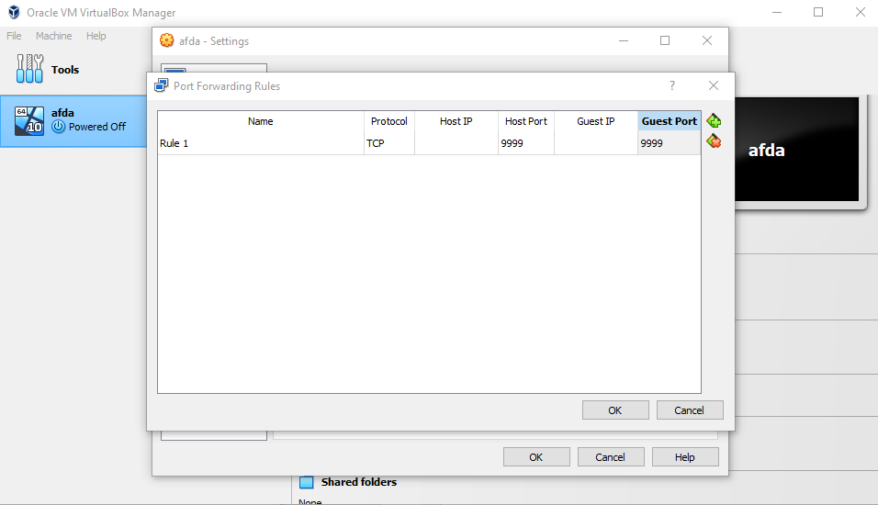

1. Open Browser and Access localhost:9999

Username is admin

Password is 1423

